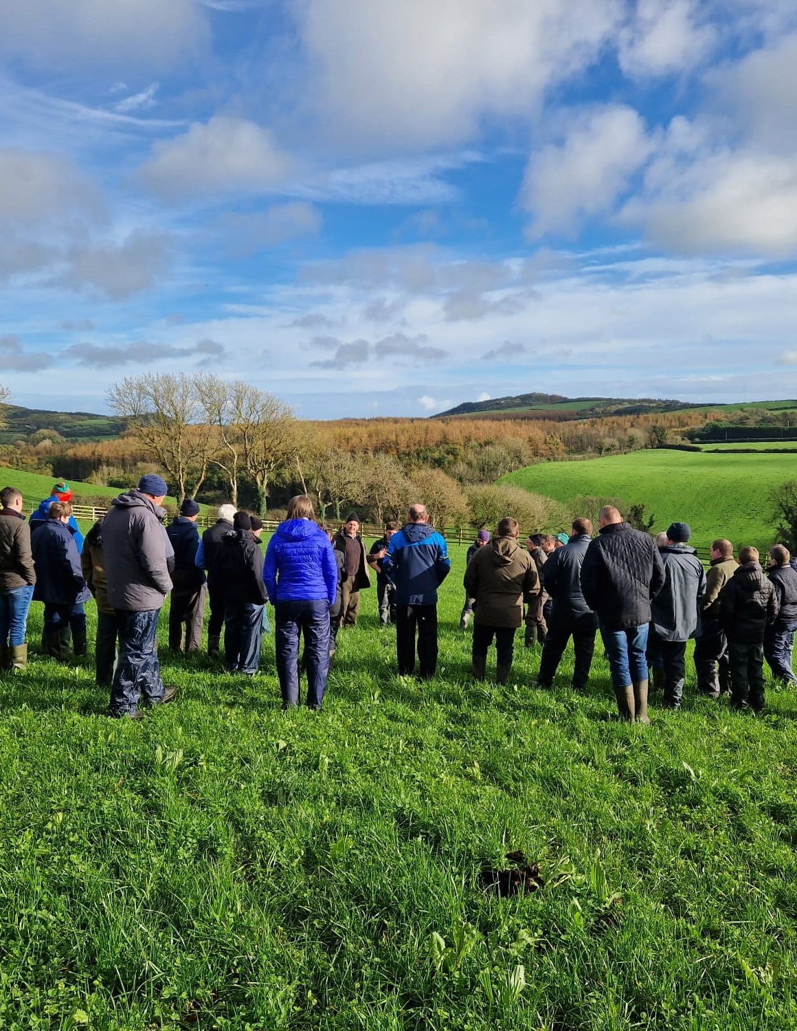
SENIOR SCIENTIFIC LEAD
APPLICATION FORM



SENIOR SCIENTIFIC LEAD

Application Form

About AgriSearch
AgriSearch is Northern Ireland's livestock research and knowledge exchange organisation. Funded by farmers and working closely with industry, government and research partners, our purpose is to improve the profitability, productivity and sustainability of livestock farming through research, innovation and evidence-based decision making. As AgriSearch enters its next phase of development, we are seeking a Senior Scientific Lead to strengthen our independent scientific capability and help ensure the organisation remains evidence led, forward-looking and focused on delivering value for farmers.

The Opportunity
This is a unique leadership role at the interface of science, farming, policy and industry. The successful candidate will provide scientific leadership across AgriSearch, helping to identify emerging challenges and opportunities, interpret complex scientific evidence and ensure farmers, industry stakeholders and policymakers have access to robust, objective and practical insight. This is not a laboratory-based research role. Instead, the position focuses on scientific scrutiny, evidence interpretation, strategic insight and helping shape the future direction of livestock farming in Northern Ireland.

Personal Information

Personal Details
Full name
Address including post code

Previous address

Home telephone no
Mobile telephone no
Email address

Qualifications (Degree / Masters (if Applicable) / PhD (if Applicable)

Qualification title | Grade obtained (or anticipated) / year

CAREER HISTORY

Please enter detail of your career history, beginning with your present or most recent position.
Company | Job title | Dates Held | Achievements and duties | Salary

Applicants should address each criterion separately. Responses should provide clear evidence of how the criterion has been met, including the role played, actions taken and outcomes achieved. Please be concise and focus on relevant examples.

Essential Criteria

10 years' experience interpreting and applying scientific evidence. (Please describe how you meet this criterion, providing specific examples of scientific evidence you have interpreted and applied, the role you played, the contribution you made and the outcomes achieved.)

Excellent analytical, communication and stakeholder engagement skills. (Please provide examples demonstrating your analytical capability and your ability to communicate complex information effectively and engage with a range of stakeholders. Clearly outline the role you played, the contribution you made and the outcomes achieved.)

The ability to influence, challenge and provide independent scientific judgement. (Please provide examples where you have used independent scientific judgement to influence decision-making, challenge established thinking or provide evidence-based advice. Clearly outline the role you played, the contribution you made and the outcomes achieved.)

Proficient in data analysis and interpretation evidenced by scientific publications. (Please provide examples of your experience analysing and interpreting data, including any relevant scientific publications, technical reports or other outputs. Clearly outline the role you played, the contribution you made and the outcomes achieved.)

Experience of working at the interface between research, industry and policy. (Please provide examples of working across research, industry and policy environments, demonstrating how you have helped translate evidence into practice, policy or decision-making. Clearly outline the role you played, the contribution you made and the outcomes achieved.)

Desirable Criteria

Have a comprehensive understanding of Northern Ireland livestock production systems, including the technical, economic, environmental and policy factors influencing the dairy, beef and sheep sectors. (Please describe your knowledge and experience of Northern Ireland livestock production systems and how this has informed your work. Provide specific examples where relevant.)

Experience of translating scientific research into practical recommendations and outcomes for farmers and industry stakeholders. (Please provide examples of how you have translated scientific evidence into practical recommendations, guidance or actions that have delivered benefits for farmers or industry stakeholders. Clearly outline the role you played, the contribution you made and the outcomes achieved.)

Referees.
Please provide details of 2 referees we may contact in relation to your application.
It is preferable that one referee is your present or most recent employer. Referees will not be contacted until interviews are completed and an offer of appointment is made. Referees should not be related to you.

Name, company and position | Capacity in which known to the candidate (work colleague, friend etc.) | Contact details  (include email & phone (preferable mobile)

I declare the above information to be complete and true to the best of my knowledge.
I have personally completed the application form.

SIGNED :.................................................................DATE : ……………………………………..

Thank you for completing this application. Please return either by email to:
sean@agrisearch.org or by post to:

Sean Kane
AgriSearch
Innovation Centre
Large Park
Hillsborough
County Down
BT26 6DR

Completed application forms must be received no later than 5.00pm on Monday 27th July 2026.

By signing and returning this Application Form, you consent to Agrisearch using and keeping information about you, provided by you or third parties, such as referees relating to your application for future employment.

Please note that as part of the recruitment process AgriSearch needs to gather personal information as supplied by you and / or third parties, such as referees, relating to your application. This information will be used in connection with making a decision in regard to your suitability for employment, and if successful will be used to form your personnel record. This information will be retained for the duration of such employment. If you are unsuccessful the information will be retained for as long as deemed necessary.

