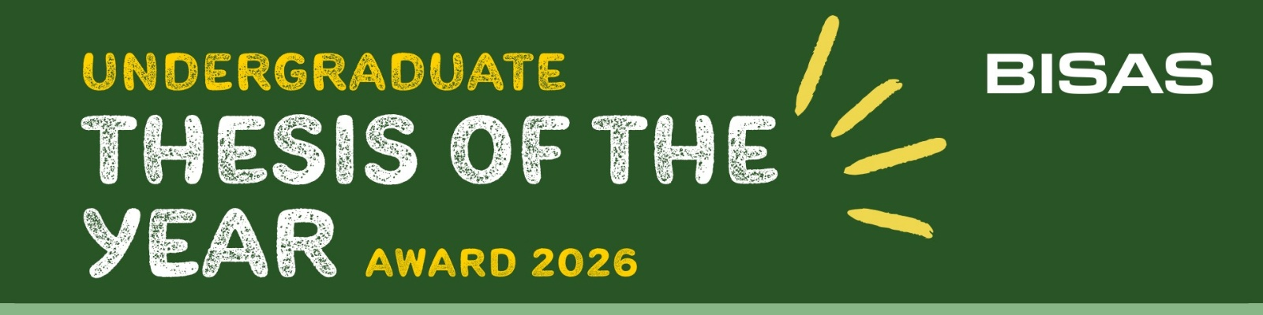

APPLICATION FORM | BISAS Animal Science Undergraduate Thesis of the Year Award 2026

Entrant 1 Name:
Entrant 1 Email:
Entrant 1 Thesis Title:
Ethical Approval Code:
Entrant 2 Name:
Entrant 2 Email:
Entrant 2 Thesis Title:
Ethical Approval Code:

Submitters Name:
Job Title:
Department:
Institution:
E-Mail Address:
Tel No:
(direct line/mobile)

PLEASE COMPLETE AND RETURN THIS FORM BY 31st July 2026 WITH ACCOMPANYING THESES OR DISSERTATIONS AND ABSTRACT FOR EACH APPLICANT TO bsas@bsas.org.uk

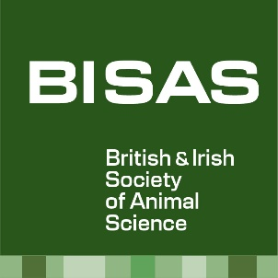

British & Irish Society of Animal Science SCIO | Charity No SC050710 | Web: bisas.org.uk

